Science
St Thomas and St Anne’s CE Primary School

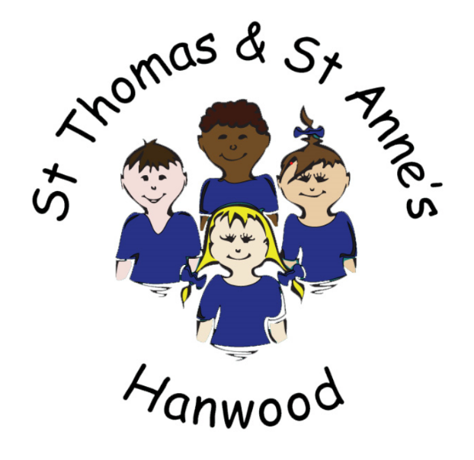

Long Term Rolling Programme
2020-2023

Intent
Our curriculum is designed to equip all children with the knowledge, including skills, that will enable them to be successful and creative in their future lives. Our curriculum is underpinned by the basic principles that:
- Learning is change to long-term memory.
- Our aim is to ensure that our pupils experience a wide breadth of study and that they have a long-term memory of an ambitious body of procedural and semantic knowledge.
At Hanwood, we believe all children are Scientists. Our Science curriculum should engage and inspire pupils to develop a lifelong curiosity for the sciences.
We intend for children to have the opportunity to learn through varied systematic investigations, where they are equipped to ask and answer scientific questions about the world around them throughout their lives. As children progress through our school, they will build on their skills in working scientifically, as well as on their scientific knowledge, as they develop greater independence in planning and carrying out fair and comparative tests to answer a range of scientific questions. Our Science lessons help children to consolidate and retain the science knowledge they have learnt, whilst also reinforcing key scientific vocabulary from each unit through retrieval practice activities.
Our Science Curriculum:
At Hanwood, we aim to develop the following threshold concepts in Science: working scientifically, biology, chemistry and physics. This will enable the children to:
- The ability to think independently and raise questions about working scientifically and the knowledge and skills that it brings.
- Confidence and competence in the full range of practical skills, taking the initiative in, for example, planning and carrying out scientific investigations.
- Excellent scientific knowledge and understanding which is demonstrated in written and verbal explanations, solving challenging problems and reporting scientific findings.
- High levels of originality, imagination or innovation in the application of skills.
- The ability to undertake practical work in a variety of contexts, including fieldwork.
- A passion for science and its application in past, present and future technologies.

Implementation
We plan for a weekly lesson of Science as a discrete subject to ensure children know and understand more. There is flexibility in how and when our lessons are taught in order to help our pupils develop and retain the information within their long-term memory.
Our rolling programme has been adopted to cater for our mixed age class structure. This will be reviewed regularly depending on the overall school structure as our class groups often change from year to year.
Our curriculum has been developed using the Twinkl Scheme of work, as well as following the Chris Quigley 'Essentials Curriculum.’ Both of these ensure that learning is engaging and developed by the pupils revisiting the threshold concepts from Year 1 to Year 6 in order to ensure all pupils progress.

Impact
We measure our pupil’s success in Science against the Threshold Concepts (key areas of learning that the children revisit in each unit of work):

Working Scientifically
- This concept involves learning the methodologies of the discipline of science.
Chemistry
- Investigate materials: This concept involves becoming familiar with a range of materials, their properties, uses and how they may be altered or changed.
Biology
- Understand plants: This concept involves becoming familiar with different types of plants, their structure and reproduction.
- Understand animals and humans: This concept involves becoming familiar with different types of animals, humans and the life processes they share.
- Investigate living things: This concept involves becoming familiar with a wider range of living things, including insects and understanding life processes.
- Understand evolution and inheritance: This concept involves understanding that organisms come into existence, adapt, change and evolve and become extinct.
Physics
- Understand movement, forces and magnets: This concept involves understanding what causes motion.
- Understand the Earth’s movement in space: This concept involves understanding what causes seasonal changes, day and night.
- Investigate light and seeing: This concept involves understanding how light and reflection affect sight.
- Investigate sound and hearing: This concept involves understanding how sound is produced, how it travels and how it is heard.
- Understand electrical circuits: This concept involves understanding circuits and their role in electrical applications.
As well as the Threshold Concepts, we measure the impact of our curriculum through the following methods:
- Photo and video evidence of the pupils practical learning – either in lessons, STEM days or other events.
- Pupil’s achievement, self-confidence, interaction with and awareness of others.
- Pupil’s self-reflection of their learning – discovering their own areas of strength, as well as areas they might like to improve upon.
- Their enjoyment and interest in Science.

year | Autumn Term |  | Spring Term |  | Summer Term
1 | Animals, including Humans (naming animals and body parts) | Seasonal Changes | Materials | Seasonal Changes | Plants | Seasonal Changes
2/3 | Uses of Everyday Materials (Y2) | Rocks (Y3) | Light (Y3)  Humans (Y2) |  | Plants (Y2) | Plants (Y3)
4 | States of Matter (Y4) | Rocks (Y3) | Sound (Y4) | Light (Y3) | Plants (Y3)
5/6 | Living Things and Their Habitat (Y5) | Living Things and Their Habitat (Y6) | Forces (Y5) | Light (Y6) | Plants (Y5) | Earth and Space (Y5)
Science Long-term plan 2020-2021

Science Long-term plan 2021-2022
year | Autumn Term |  | Spring Term |  | Summer Term
1 | Animals, including Humans (naming animals and body parts) | Seasonal Changes | Materials | Seasonal Changes | Plants | Seasonal Changes
2/3 | Animals, including Humans (Y2) (Health and growth) | Animals, including Humans (Y3) (Skeletons) | Uses of everyday Materials (Y2) (Recap/Review) | Forces and Magnets (Y3) | Living things and their habitats (Y2) | Seasonal Changes (Y2)  (Recap/Review)
4/5 | Animals, including Humans (Y4) (Teeth, eating and digestion) | Animals, including Humans (Y5) (Changes in Humans as they grow) | Forces and Magnets (Y3) | States of matter (recap and review) (Y4) Properties and changes of materials (Y5) | Electricity (Y4) | Living things and their habitats (Y4)
5/6 | Animals, including Humans (Y5) (Changes in Humans as they grow | Animals, including Humans (Y6) (Health and circulation) | Evolution and inheritance (Y6) | Properties and Changes of materials (Y5) | Electricity (Y6) | Recap/Review

year | Autumn Term |  | Spring Term |  | Summer Term
1 | Animals, including Humans (naming animals and body parts) | Seasonal Changes | Materials | Seasonal Changes | Plants | Seasonal Changes
2/3 | Uses of Everyday Materials (Y2) | Rocks (Y3) | Animals, Including Humans (Y2) | Light (Y3) | Plants (Y2) | Plants (Y3)
4/5 | Living Things and Their Habitat (Y5) | States of Matter (Y4) | Sound (Y4) | Forces (Y5) | Earth and Space (Y5)
6 | Evolution and inheritance (Y6) | Living Things and Their Habitat (Y6) | Light (Y6) | Earth and Space (Y5) |  | Electricity (Y6)
Science Long-term plan 2022-2023

2023/2024 | Autumn 1 | Autumn 2 | Spring 1 | Spring 2 | Summer 1 | Summer 2
Fir (Y1) | Animals, including humans |  | Materials |  | Plants
 | Seasonal changes
Elm (Y2/3) | Animals, including humans (Y3) | Use of everyday materials (Y2) | Rocks (Y3) | Forces (Y3) | Living things & their habitats (Y2) | Plants (Y2)
Ash (Y3/4) | Animals, including humans (Y3) | States of matter (Y4) | Rocks (Y3) | Sound (Y4) | Forces (Y3) | Electricity (Y4)
Oak (Y5/6) | Animals, including humans (Y6) | Evolution & Inheritance (Y6) | Light (Y6) | Materials (Y5) | Electricity (Y6) | Living things & their habitats (Y6)

